**SOUNDCARE HEALTH ANALYTICS, TECHNICAL REPORT**

**DATA ANALYST: KIGBU ISTIFANUS**

**STUDENT ID: VEPH/20B/DA057**

**Task 21**

**Outline**

• Introduction

• Data cleaning

• Pre-analysis

• Industry type

• Stakeholder

• Value of data to the company

• Story of Data

• Pre-analysis

• In-analysis

• Data visualization and Chart

• Observation and Recommendation

• Conclusion

• References and Appendices.

**Introduction**

SoundCare is an industry that operates at the intersection of music therapy and healthcare analytics, leveraging data-driven insights to enhance mental health treatment. By analyzing how individuals across different age groups engage with music, the platform uncovers critical connections between listening behaviors and mental health conditions such as anxiety, depression, insomnia, and OCD.

With music therapists as key stakeholders, SoundCare aims to empower practitioners with personalized recommendations, identifying music genres and patterns that best support patients facing emotional and psychological challenges. Success is measured by the platform’s ability to deliver tailored, evidence-based music therapy interventions that contribute to improved mental health outcomes and tangible gains in overall well-being.

**Data Cleaning**

1. To guarantee the accuracy and dependability of the sales performance analysis, an extensive data cleansing process was carried out. This process involved several key steps aimed at improving consistency, removing errors, and preparing the dataset for effective analysis.
2. Standardizing Inconsistent Data – Categorical variables were normalized to address discrepancies in labeling, ensuring a consistent format throughout the dataset. This step was crucial for aligning customer information, dealer records, and vehicle specifications under a unified structure
3. Duplicate Detection and Removal – The dataset was systematically reviewed to identify and eliminate duplicate records. By removing redundant entries, data integrity was preserved, minimizing the risk of skewed results and supporting a more accurate assessment of sales trends.

**Pre-Analysis**

**Project Split:**

The following steps were performed during this session:

Data partitioning – The dataset was divided into two categories, representing independent variables (category 1) and dependent variables (category 2) for further analysis.

**Category One- Independent Values**

* Age
* Primary Streaming Service
* Hours per Day
* Favourite Genre

**Category Two-Dependent Values**

* Anxiety Level
* Depression
* Insomnia
* OCD
* Music Effect

This dataset reveals how people across different age ranges engage with music and examines how their listening behaviors affect mental health conditions like anxiety, depression, insomnia, and OCD.

**Industry Type**

Music Therapy / Healthcare Analytics

**Stakeholder:**

The Stakeholder of the company is Music Therapist

**Story Of The Data**

This dataset explores how individuals across different age groups engage with music and how their listening behaviors relate to mental health conditions such as anxiety, depression, insomnia, and OCD. By analyzing factors like genre preferences, listening frequency, and context, it uncovers patterns that may influence emotional well-being and symptom management. The data also highlights age-related differences in how music is used as a coping tool or therapeutic aid.

The findings aim to support the development of personalized music therapy by providing evidence-based insights into the connection between music and mental health. This empowers music therapists and healthcare practitioners to design tailored interventions that incorporate music strategically into treatment plans, ultimately promoting better psychological outcomes and overall well-being.

**What Success Means**

In this field, success lies in pinpointing music genres that support mental health concerns such as anxiety, depression, and insomnia. By incorporating personalized music therapy into treatment regimens, practitioners help patients achieve tangible gains in overall well-being.

**Pre-analysis**

These are the initial trends that were observed.

**Potential Analysis**

* Advise using music as a mental health therapy specifically for the age groups that benefit the most.
* Determine the ideal amount of daily listening time that enhances mental well-being for individuals with mental health issues.
* Identify the streaming service that most effectively promotes mental wellness.
* Suggest the top music genres that best support the management of mental health conditions such as anxiety, depression, OCD, and insomnia.

**Initial insight:**

* Advise using music as a mental health therapy specifically for the age groups that benefit the most.
* Determine the ideal amount of daily listening time that enhances mental well-being for individuals with mental health issues.
* Identify the streaming service that most effectively promotes mental wellness.
* Suggest the top music genres that best support the management of mental health conditions such as anxiety, depression, OCD, and insomnia.

.

**In-analysis Observations and inside**

Upon completing the analysis and generating the charts, the following insights were identified:

* The most significant positive impact of music on mental health was observed among participants aged 10–24, whereas individuals aged 70 and above reported no noticeable changes in their mental well-being.
* Participants who listened to music for 0–4 hours (329 individuals) showed the highest improvement in mental health, compared to those who listened for 20–24 hours.
* A large portion (347 participants) indicated that using Spotify as their music streaming platform helped improve their mental health more than other streaming services.
* 74% of participants reported that music positively influenced their mental health, while 24% noticed no change, and 2% said it had a negative effect.
* Individuals experiencing depression showed a strong preference for Lofi music, followed by genres such as Hip-hop, EDM, Rock, and Metal.
* Among those dealing with insomnia, Lofi emerged as the most favored genre, with Gospel, Metal, video game music, and EDM also ranking high in interest.
* Folk music was found to be the most beneficial for individuals with anxiety, with K-Pop, Hip-hop, Rock, and Lofi being other commonly preferred genres.
* Lofi was the top-rated genre among participants with OCD, though by a narrow margin. Other popular choices included Rap, EDM, Pop, and Jazz.

**In-analysis Insight**

* Music therapy initiatives should prioritize young people between the ages of 10 and 24.
* Promoting moderate music listening—between 0 to 4 hours daily—may yield the most positive mental health outcomes.
* Spotify can serve as a central platform for distributing therapeutic music content.
* It's important to explore why certain individuals see no benefits or experience negative effects from music therapy, in order to create personalized treatment approaches.
* Lofi music has strong therapeutic potential and should be integrated into mental health and wellness programs.
* Anxiety: Incorporate folk music to help ease symptoms.
* Insomnia: Use Lofi and Gospel music to encourage relaxation and restful sleep.
* Depression: Opt for mood-boosting genres like Hip-Hop, EDM, and Rock.
* OCD: Include Rap, Pop, and Jazz to support concentration and provide structure.
* Develop curated playlists on platforms such as Spotify aligned with these preferences to maximize therapeutic impact.

**Data Visualization and Charts**

**Dashboard**

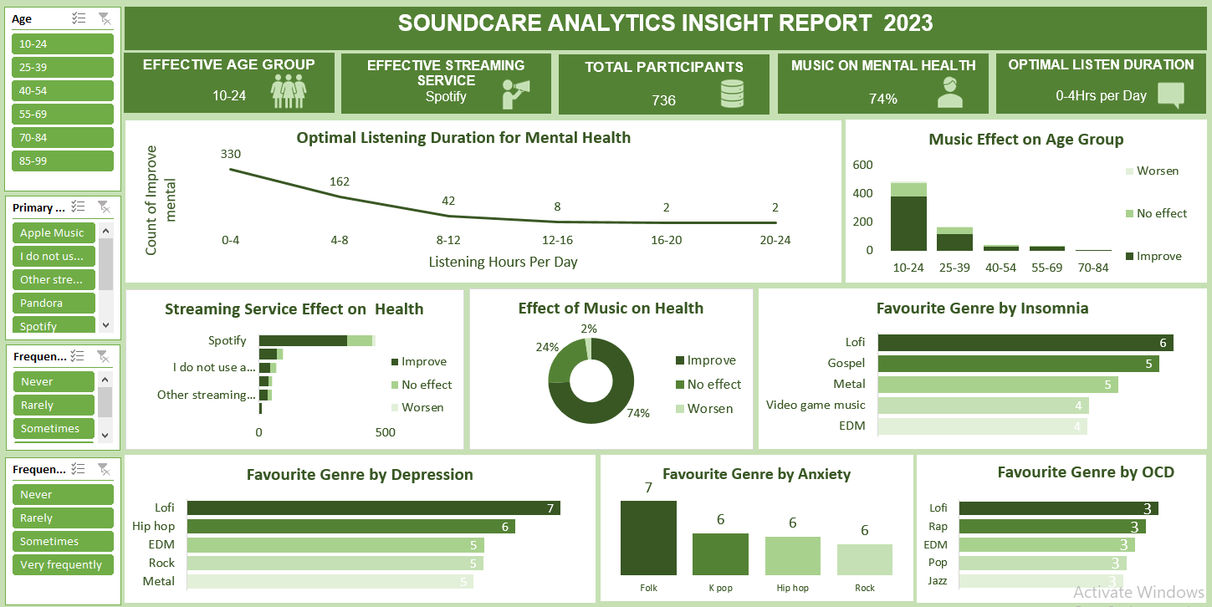

**Observations**

* Individuals aged 10–24 showed the most significant improvement in mental health from music, whereas those aged 70 and above reported no noticeable effects.
* Participants who listened to music for 0–4 hours (329 individuals) reported the highest improvement in mental well-being, compared to those who listened for 20–24 hours.
* When focusing on the 10–24 age group, a similar pattern emerged—those who listened to their favorite genre for 0–4 hours experienced greater mental health benefits.
* A majority of participants (347) noted that listening to music on Spotify positively impacted their mental health more than other platforms, with the 10–24 age group also favoring Spotify.
* Overall, 74% of respondents said music improved their mental health, 24% saw no change, and 2% felt worse. Specifically, within the 10–24 age group, 77% reported positive effects from music.

**Recommendation**

* Focus on Youth for Music Therapy: Future mental health initiatives should give priority to younger age groups when implementing music-based therapies.
* Promote Ideal Listening Time: To maximize effectiveness, music therapy should be limited to sessions lasting between 0 to 4 hours.
* Utilize Spotify as the Go-To Platform: Given its popularity, Spotify should be used to deliver tailored playlists that support mental health treatment.
* Personalize Music Therapy: Therapy should be adapted to individual preferences, allowing users to choose genres and listening durations that suit their needs for optimal outcomes.

**Conclusion:**

The analysis shows that music significantly improves mental health, especially for individuals aged 10–24, with the greatest benefits observed at 0–4 hours of listening time. Spotify was the preferred platform for music engagement, and overall, 74% of participants reported positive effects on their mental well-being. These findings suggest that music therapy should prioritize younger audiences, promote shorter, structured listening sessions, leverage popular platforms like Spotify, and be personalized to individual preferences in genre and listening habits to maximize therapeutic outcomes.

**Reference**

Kaggle. (2023). *World happiness report data* [Data set]. <https://www.kaggle.com/datasets/> johndoe/world- happiness-report-data